Online Examination System

By: Mehak Basrani

IT-2K19-31

***Software Project Management Plan***

 Abstract:

ONLINE STUDENT TEST is a project developed to provide an easy way to develop student’s skills. This project helps users by analysing the areas where students are weak and allows tests accordingly.

Introduction:

On-line Exam System is very much important for any Educational Organizations to prepare their students for any exams by saving the time. It will take check the paper and generate mark sheets as well. It will also help the Organization to test the students and develop their skills.

Purpose:

The purpose of Software Requirements Specification (SRS) document is to describe the external behavior of the Online Examination System. Requirements Specification defines and describes the operations, interfaces, performance, and quality assurance requirements of the Online Examination System. The document also describes the nonfunctional requirements such as the user interfaces. It also describes the design constraints that are to be considered when the system is to be designed, and other factors necessary to provide a complete and comprehensive description of the requirements for the software. The Software Requirements Specification (SRS) captures the complete software requirements for the system, or a portion of the system. Requirements described in this document are derived from the Vision Document prepared for the Online Examination System.

PROJECT PLAN

This document will propose all features and procedures to develop the system. This document specially containing details about objectives, scope limitation, process model, primary requirements, team development, possible project risks, project schedule, and finally monitoring and reporting mechanisms. On-line Exam System is very useful for Educational Institute to prepare an exam, safe the time that will take to check the paper and prepare mark sheets. It will help the Institute to testing of students and develop their skills. But the disadvantages for this system, it takes a lot of times when you prepare the exam at the first time for usage. And we are needs number of computers with the same number of students.

The effective use of "Online Examination System", any Educational Institute or training centers can be use it to develop their strategy for putting the exams, and for getting better results in less time.

 Scope and limitations:

* On-line Exam system is designed for Educational Institutes (like schools, universities, training centers).
* The system handles all the operations, and generates reports as soon as the test is finish, that includes name, mark, time spent to solve the exam.
* Allow students to see or display his answers after the exam is finish.
* The type of questions is only multiple choice or true and false.

Project Organization:

|  |  |
| --- | --- |
| **Job Title** | **Description** |
| Project Manager | To manage all processes in the project |
| SW Designer | To design the models and diagrams that helps the programmer in implementation phase |
| Two Testers | One from outside the team and the other from the inside the project team. |
| Two programmers | Professional in ASP.NET and SQL To programming the processes of the project. |
| SW Analyst | . To analyze the requirements of On-Line Exam System. |
| Writer | Collects drafts from each member. Rewrite and reformate the documents come from each member. Have good print skills. Have a good skill to correct grammars of statements. |

Risk analysis and risk planning:

|  |  |  |  |
| --- | --- | --- | --- |
| **Risk** | **Probability** | **Effects** | **Risk planning strategy** |
| The experience staff in the team leave the project before it is finish, or someone was ill | low | serious | Use more than one staff for each section, which might minimize this risk. Also, manager tries to increase salary for him. |
| The methodology to solve the problem can't work in a proper manner. | high | serious | Must be study more than one methodology to minimize this risk. |
| Budget does not enough or there is no budget. | low | catastrophic | Put a condition in the contract if there any more expenses, the funded side must be pay it. To avoid this risk. |
| HW requirement can't come in the time. | moderate | serious | See if there is any more time to delay the project or not. If there is no more time work by the team computers, to minimize this risk. |

Project management approach:

**Software Process Model:**

To solve an actual problems in an industry, software developer or a team of developers must integrate with a development strategy that include the process, methods and tools layer and generic phases. This strategy is often referred to a process model or a software developing paradigm.

Our project follows the waterfall model.

The steps of waterfall model are:

* Requirement Definition
* System and Software Design
* Implementation
* Integration and System Testing
* Operation and Maintenance

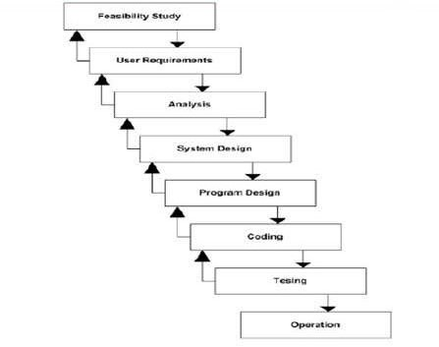

Software Organizational Structure

**Project Manager**

SW Designer

SW Analyst

Tester

Programmers

Writer